Checkers

Project Design
By Group 3 of Software Development with C++

  - Table of Contents
Introduction………………………………………………………………………………………………………….3
Architecture………………………………………………………………………………………………………….4
Use Cases…………………………………………………………………………………………………………….6
UML Diagram…………………………………………………………………………………………………………7
Test Cases…………………………………………………………………………………………………………..12
Summary……………………………………………………………………………………………………….……13

Introduction
Checkers is a turn-based game where both players must successfully eliminate all pieces on the board that belong to their opponent. This is achieved by allowing the players to move their pieces across the board through diagonal movements. If two opposing pieces are located next to each other on their respective squares, they may choose to jump over the other piece if there isn’t a piece occupying the space that the jumping piece will land on. Additionally, the pieces may only move in a direction towards their opponent. Lastly, if a piece reaches the end row of the board opposite of where they started then they will be “kinged”. King pieces can move in any diagonal direction across the board. This C++ remake of the classic checkers game will aim to provide a version that works within a CLI.

This document will contain the following information on the project:
- A diagram that illustrates the proposed system architecture.
- A set of use-cases to show how the user will interact with the application.
- A UML diagram of the proposed classes for the system.
- A set of test cases to guide testers in diagnosing errors and deficiencies.
- A closing summary of the project design.

Architecture
- Our team will be using the C++ programming language to build this project, and our IDE of choice will be Visual Studio.
- Our interface will solely be through the terminal program, which will be where the users see the updated game board and type the next move they will make.
- For this, we shall take the approach of Object-Oriented Design. Breaking parts of the game into classes. Additionally, these classes may be separated into their own files with a header to be used for each to make them separate from the main program file.
- These classes may include: the board, the piece, and the main game class. Where main will be the main program file to initialize the program.

Architecture

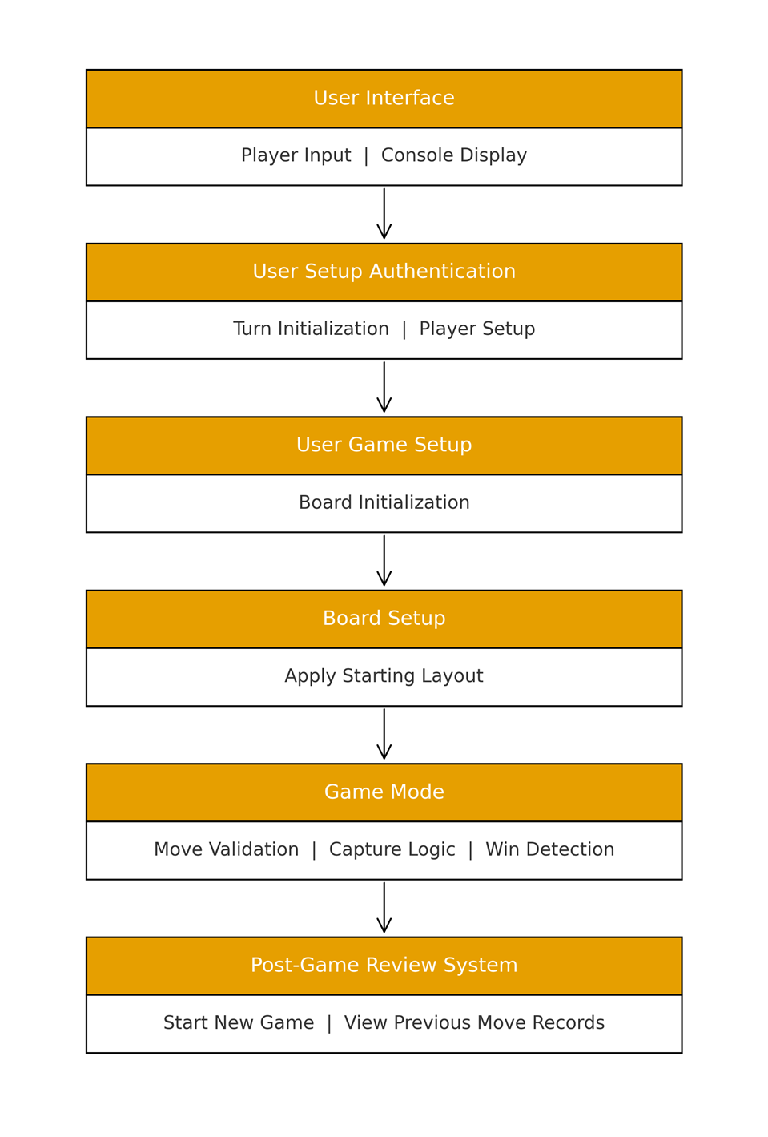

Use Case

- Organizes functional requirements
- Models the goals of user interactions
- Records paths (called scenarios) from trigger events to goals
- Describes one main flow of events (also called a basic course of action), and possibly other ones, called exceptional flows of events
- Is multi-level, so that one use case can use the functionality of another one.
- Use cases can be employed during several stages of software development, such as planning system requirements, validating design, testing software, and creating an outline for online help and user manuals.

UML Diagram
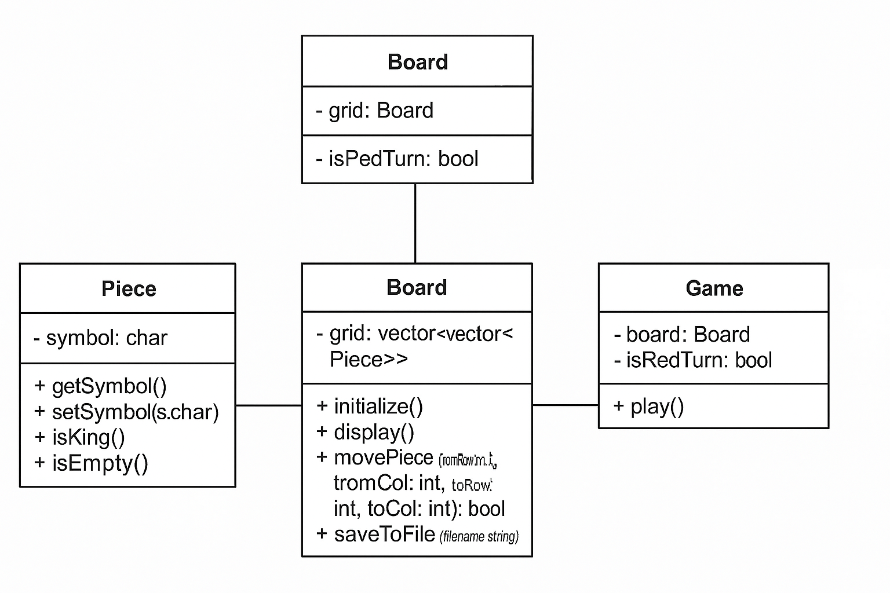

UML Diagram
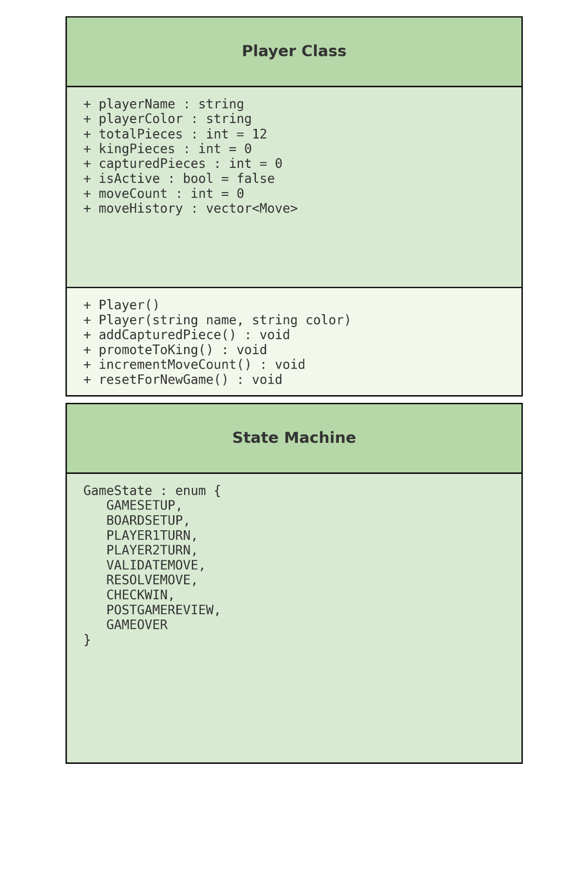

Players and Game Setup

Enter User Information



Display Board
Move Entry and Validation

Player

Review Game Sequence or New Game

Exit Game

Turn Sequence And Pieces

View Board State

Enter Move

If Move takes Piece Move again

Player
If Piece lands on final opposing Rank, become King

Turn Sequence And Pieces

View Board State

Declare Victory

Player
End Game Review

Test Cases
Manual Test Cases
- Basic Move Flow
- Input: d3 e4
- Expect: Board updates; turn toggles to Black; no “Invalid move!”
- Invalid Move
- Input: Move onto an occupied square (e.g., from b2 to a1 at start where target is occupied).
- Expect: “Invalid move!”, turn unchanged.
- Save & Load Round Trip
- Make 2–3 moves → save → quit.
- Restart → load.
- Expect: Board matches saved state.
- Quit
- Error Paths
- Delete checkers_save.txt → run load.
- Expect: “Error loading file.” message, no crash.

Summary
This project delivers a command-line implementation of the classic Checkers game using Object-Oriented Programming (OOP) principles in C++. The design emphasizes modularity, maintainability, and clarity through the separation of concerns across three core classes:

- Piece: Represents individual game pieces and their state.

- Board: Manages the 8×8 grid, piece placement, movement, and persistence.

- Game: Controls the game loop, user interaction, and turn logic.
The architecture is structured for scalability, allowing future enhancements such as capture rules, king promotion, and AI opponents. Supporting diagrams include a UML class diagram and a Use Case diagram, illustrating system components and user interactions. A comprehensive set of manual and unit test cases ensures correctness in initialization, movement, saving/loading, and error handling.
By leveraging OOP design, this project achieves:

- Encapsulation for data integrity.
- Abstraction for simplified interactions between components.
- Modularity for easier maintenance and extension.
Overall, this design provides a robust foundation for a functional and extensible Checkers game in a CLI environment.

